BEDROOM MAKEOVER
PROJECT

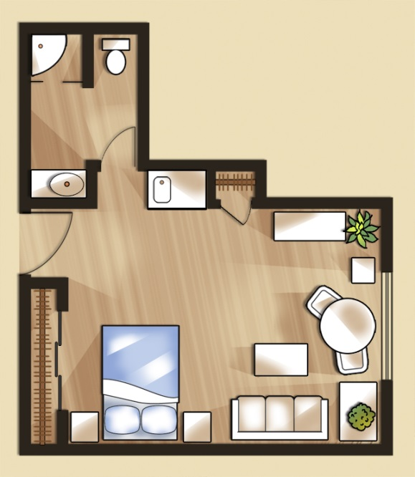

NAME: ____________________________________#_________________

BEDROOM MAKEOVER PROJECT

GOAL: After this unit, you will understand how to calculate sales tax for a purchase, find the amount of materials needed to cover a room, write a check and keep a check register.

The basic standards and major focus of the lesson include:
- Numbers & Operations with decimals (+,-,*,/), including sales tax
- Measurement, including area
- Problem Solving & accuracy, including keeping a check book account
- Decision Making and real world connections
TASK: You have the opportunity to completely redesign your bedroom. How imaginative will you be? Where will the windows go, the door? What color paint will you use? Will there be a study area and a play area? Remember to think about the size of the space and cost while you are creating your room. You will need to keep to your budget as well and keep track of your finances. If you go over your budget, you have to speak to the banker, Mrs. Conrad. If you need a loan (borrow money from the bank), you will have to meet with the banker and convince her why it will be beneficial to your design.

Student: ___________________________ Parent: ____________________________
*Although some materials may be needed to be brought in, the majority of the project will be done in school.
Name: ______________________________
Rubric Bedroom Makeover Project

Possible Actual
Bedroom Makeover Worksheets 20 __________

Presentation
Detailed Floor Plan 10 ___________
-magazine collage
-3D shadow box
-architectural design plan (drawn/computer)

Summary (1 paragraph – typed) 4 ___________
Flooring Sample (actual or printed) 1 ___________
Paint Sample (actual or printed) 1 ___________
Check Register 2 ___________
Checks (written to Home Depot or Lowes) 2 ___________
Quality & Neatness 5 ___________
Accuracy 5 ___________
TOTAL 50 ___________

Name:______________________#________ Bedroom Makeover Worksheet 1
WORK SPACE
Floor
Length: ___________________

Width: ___________________

Area: __________________ sq. ft.

Carpet or hardwood? __________________________ WORK SPACE:

Cost per square foot: $_________________________

Area x Cost per square foot: $________________________
(Round to the nearest hundredth)

Sales tax: Cost x Tax $ ______________________
Sales tax: 6.25%

Total carpet cost + Sales tax $ _______________________

Name: ______________________________#_________ Worksheet 2
Paint Cost Work Space:
Height of walls: _______________ feet (ft.)
Area of Walls:
*Assume perfect walls
*Don’t forget to subtract windows and doors!
Wall 1: _______________________# of windows _______ door_______
Wall 2: _______________________# of windows _______ door________
Wall 3: _______________________# of windows _______ door________
Wall 4: _______________________# of windows _______ door________

Area of ceiling:
(Same as area of floor) _____________________ sq. ft.
Total Area:
Area of walls + Ceiling __________________ sq. ft.
Paint
Cost of paint per gallon: __________________
1 gallon will cover 350 square feet of walls and ceiling
I will need __________________ gallons.

# of gallons x cost per gallon = paint cost $_______________
Round to the hundredth
Sales Tax $_______________
Paint + Tax = Total Paint Cost $ ______________
HOMEWORK: DAY 1
Name: __________________________#___________ Date:________________________
Measure the area of your bedroom. Find the following in feet. If you measure in inches, make sure your convert to feet.
Work Space
Length: ____________________________ feet

Width: _______________________________feet

Area (length x width):_____________________square feet

HOMEWORK: DAY 1
Name: __________________________#___________ Date:________________________
Measure the area of your bedroom. Find the following in feet. If you measure in inches, make sure your convert to feet.
Work Space
Length: ____________________________ feet

Width: _______________________________feet

Area (length x width):_____________________square feet

