Light Energy Notes

- Light travels in straight lines and in waves.
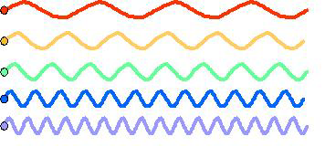
- The light we see (visible light) is part of the electromagnetic spectrum.
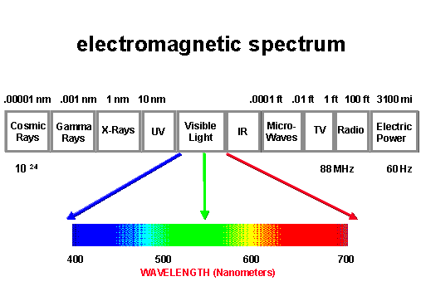

- White light is made up of the colors in the visible spectrum (rainbow/ROYGBIV).
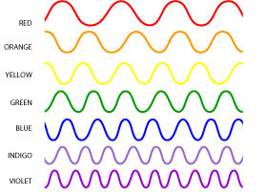
- The farther you are from a light source, the dimmer the light.

- Reflection: bouncing of light/ mirror

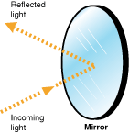

- Refraction: bending of light/ prism
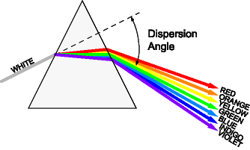

- The Law of Refraction: the angle of incidence is equal to the angle of reflection
