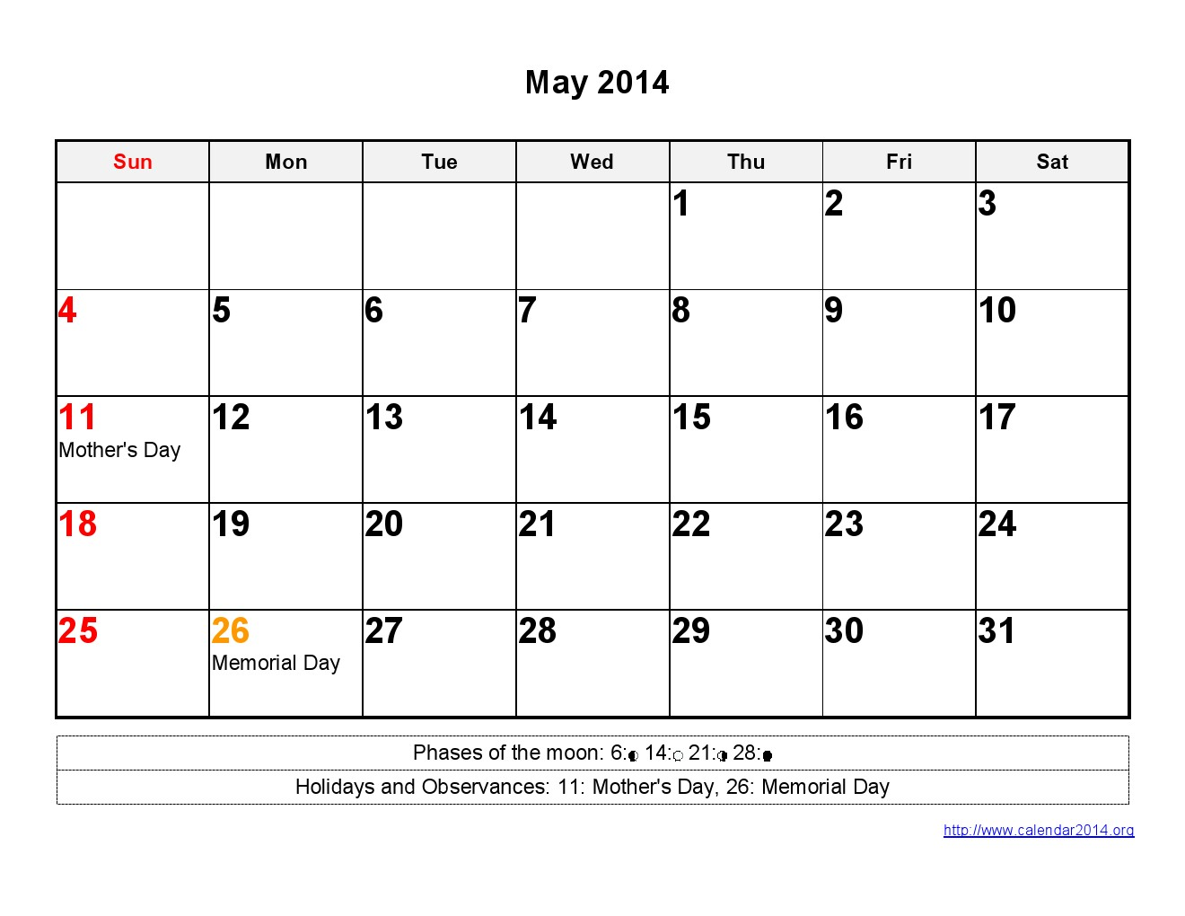

**Week 1**

**Week 3**

**Week 2**

**Week 1**

**Week 3**